**2012 Boston Student Sailing Expeditions**

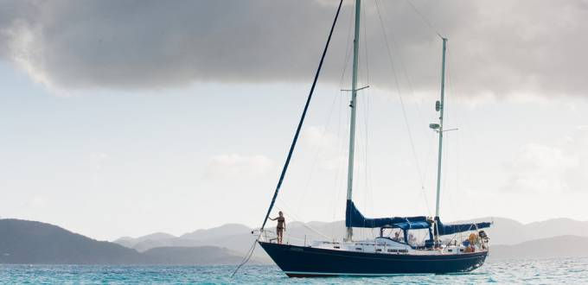

**What:** week-long sailing trips with fellow students- sailing, snorkeling, fishing, hiking, and exploring islands on a 42 foot sailboat. This is a good trip for students who are adventurous, in at least moderately good shape, and who don’t mind sharing a small space with strangers and not showering every day. Must also be able to swim. No sailing experience is needed.

**Where:**

1. **The US and British Virgin Islands**- 1-2 trips in May/June will sail from St Thomas to explore the British Virgin Islands for the week- Jost Van Dyke, Tortola, Virgin Gorda and Anegada, then back to St John/St Thomas
2. **Puerto Rico**- 1 trip in June will explore Vieques and Culebra, the Spanish Virgins. We’ll sail, snorkel, hike and explore the world’s brightest bio-luminescent bay on Vieques during the new moon in late June.
3. **Grenada, Carriacou, St Vincent**- 1-2 trips will explore the southeastern Carribean before classes start again in August!

**Who*:*** 6 spots are available for each trip not counting captain- most are Tufts and Harvard graduate students but all are welcome.

**Why:** I started these trips this year to offer opportunities for Tufts students to have affordable sailing trips with fellow students for spring break and summer, and to help me pay for grad school. We decided to open these trips up to students from other Boston schools for the summer trips, so we hope you’ll join us to explore!

**When:**

May 16- 22- British Virgin Islands I (Jost to Anegada)

June 2- 8- British Virgin Islands II

June 16-22- Puerto Rico (Spanish Virgin Islands)

August 11-17 Grenada

August 25-31 Grenada

**Cost:** $105/day, $735 for the week. This covers your berth, breakfast/lunch, fuel, mooring costs and British customs entry fees. Dinners will be cost-share, buying groceries and cooking on the boat, and we might eat out 1-2 times. Does not include: flight to/from St Thomas or on-island transportation or activities. Please note a non-refundable deposit of $270 will be required one month in advance to hold your spot.

**Sign-up: Email me at** [**michael.graham@tufts.edu**](mailto:michael.graham@tufts.edu)**, and sign yourself up on this google doc:** [https://docs.google.com/spreadsheet/ccc?key=0Ah3e22xRNvr6dEN3dkJjU0pHbnNod0FyeFZ6SHdyc0E](https://exchange.tufts.edu/owa/redir.aspx?C=b4513b768d5247158775039d9e8be04f&URL=https%3a%2f%2fdocs.google.com%2fspreadsheet%2fccc%3fkey%3d0Ah3e22xRNvr6dEN3dkJjU0pHbnNod0FyeFZ6SHdyc0E)

**About the boat:** 'Kallista' is a 42 foot two masted sailing ketch based in St John, USVI. There are three basic cabins with 2 berths each, restroom (head), full kitchen (galley) and a large cockpit. The captain is a current Tufts graduate student with a 50 ton Master's license. The boat has full offshore safety and communications equipment and insurance. See photos and info at [www.sailkallista.com](http://www.sailkallista.com).

**Example Itinerary**

This was our basic itinerary for the spring break trip in March. The exact itinerary is subject to weather and what the group wants to do (e.g. spend an extra day at a particular reef).

**Day 1-** *Fly into St Thomas, meet at boat and prepare for passage. Sail from St Thomas USVI to Jost Van Dyke, BVI*

Introduction to the boat, safety briefing and overboard drills, basic sailing discussion. We'll sail to the east end of Jost Van Dyke where we will hike to the bubbly pools and explore Sandy Cay.

**Day 2- Explore St John-** Sail from St Thomas to Maho and Cinnamon Bay.

**Day 3-** *Jost Van Dyke to Tortola, BVI*

We will get up early and sail from Jost to the northern beaches of Tortola including Apple Bay. Snorkeling, beach time and exploration of the main capital Road Town.

**Day 4-** *Explore Tortola, the largest of the Virgin Islands*

**Day 5-** *Tortola to Virgin Gorda, BVI*

We'll sail 15 miles further east to Virgin Gorda, the easternmost island in the British chain. We'll sail past Richard Branson's Necker island into North Sound, visit the natural baths, hike and explore the island.

**Day 6-** *Virgin Gorda to Norman Island, BVI*

We'll sail back down the chain into the heart of the British Virgin Islands to Norman Island. Here we'll snorkel the Indians and caves before crossing the Sir Francis Drake passage for an overnight open ocean passage to St Croix in the US Virgin Islands, 30 miles away.

**Day 7-** *Norman Island to St Thomas*

Arriving mid-morning we will check back into US customs and spend the rest of the day exploring the island and surrounding waters. (Note: the St Croix passage is weather depending. The alternate will be Anegada in the British Virgin Islands)

**Visa requirements for UK and US**

**US students** can check in and out of British customs without problem, no visa is needed

**International students**- most should not have a problem, but check British visa requirements for your country, and check that your US visa allows reentry back to the US when you leave the country. We will be in the British Virgin Islands for 4-6 days total.

**What to bring**  
*A suggested packing list for sailing in the Virgin Islands:*

* Lightweight waterproof jacket
* Swimsuit (x2 if possible)
* Sunglasses
* Bug repellent
* Lightweight hiking shoes
* Sunscreen!
* Lightweight long sleeved shirt
* Hat
* Personal snorkel (there are some on the boat but for best experience bring your own)
* Medications (including seasickness patch or pills if needed)
* Headlamp
* Non-skid/marking shoes
* Cash/ATM/Credit card for meals out

**Contact details**

For more information call or email Michael Graham 202 549 5643 michael.graham@tufts.edu

